**3.5**

**Develop efficient & effective ICT-based solutions**

**[collaborative technology]**

ICT-based solutions are a system for gathering technology and applications together with the information, processes, and the people to create, spread, store, and manage information and data, needed to form collaborative websites, such as;

* Teams
* Zoom
* Adobe connects
* LinkedIn
* Google meet

These sites are for groups to communicate together over the internet, usually free of charge, where they can share files, chat, and calls, etc.

The google platform has many applications for its user’s, and by using Google Docs you can share documents, spreadsheets, forms, and slides, sharing a document means a group can edit a report/letter/financial sheet/presentation slide and fill in forms. The group can share the ‘file’ and edit it together, add comments and chat…

**Google docs**

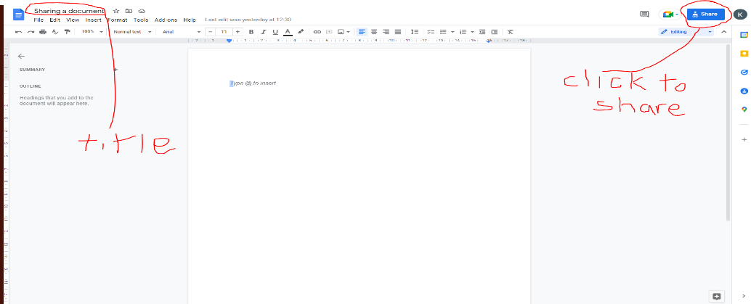

*

You can then add an email address to the ‘**share with people and groups’** link or get a link with an email address embedded into the ‘**copy Link’**, where you then paste into an area of a 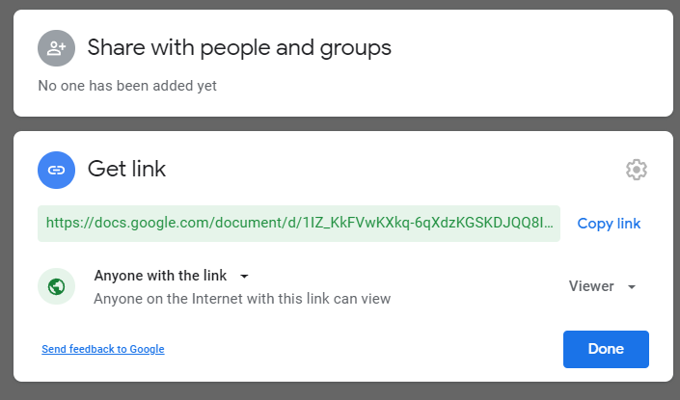collaborative page, such as a **chat box/room**, so you’re intended invitees can click to gain access to the document you wish to share and work on collaboratively.

You can choose here the level of access rights you intend for the sharer

**Viewer**

*People can view but can’t change or share the file with others.*

**Commenter**

*People can make comments and suggestions but can’t change or share the file with others*.

**Editor**

*People can make changes, accept, or reject suggestions, and share the file with others.*

The recipient will see the above link, which will direct them to the document.

Once the document is opened, the collective participants can read/write or share according to the rights allowed by the owner. The document can be added to by all the invitees, and the group can use the document has a temporary chat box. The participants can add comments where they have added data/images etc.

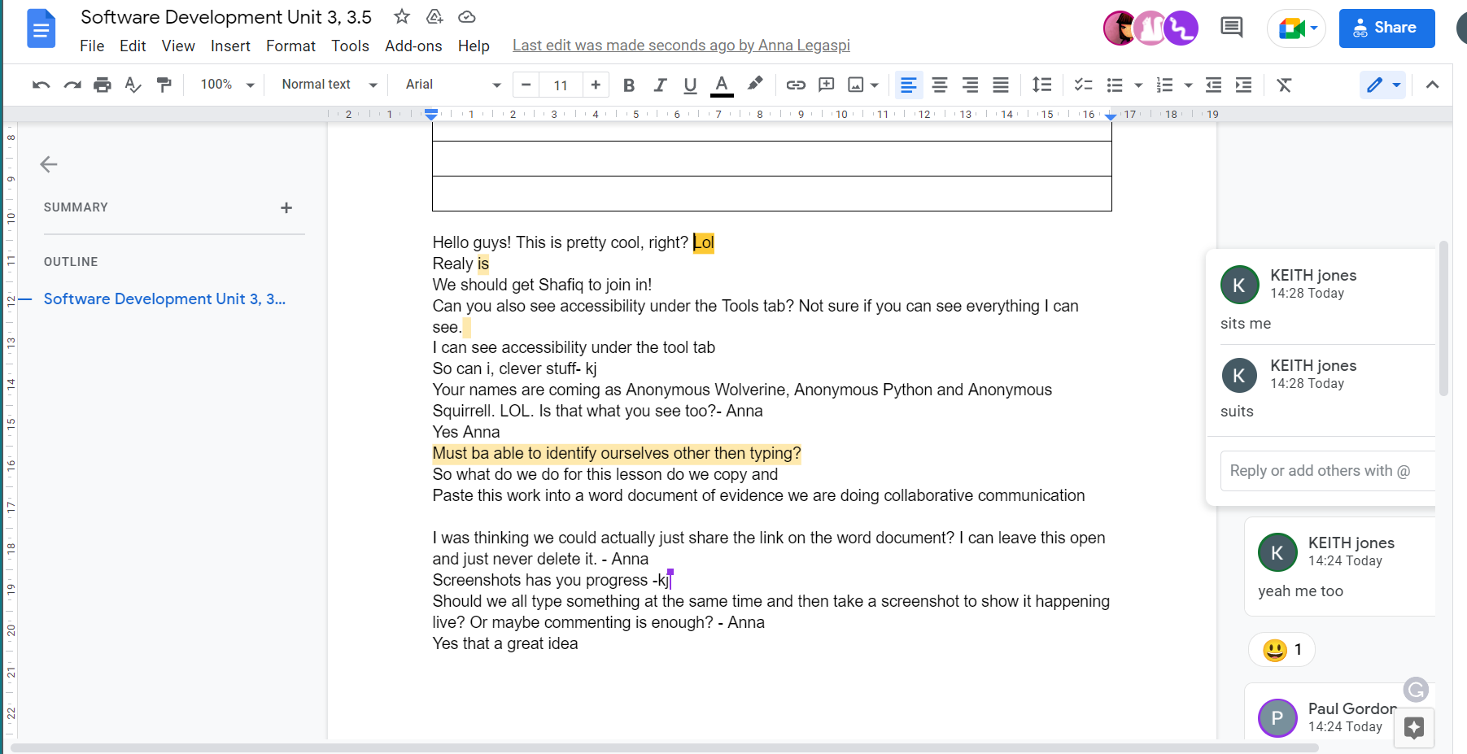

There are many types of devices that can be used for collaborative applications;

* Desktop
* Laptop
* Tablets
* Mobiles {*limited accessibility due to size*]

Ideally the users would access the application with a desktop or Laptop, this gives them a bigger hard drive and therefore faster than a mobile phone, they could also have a number of servers open to ensure different formatting can be viewed, this ca be useful if members of the group have problems with colour blindness etc, or change font size for easier viewing.

# Bibliography

kj. (2022, April 23). *Best Practices for Sharing in Google Drive*. Retrieved from M information and technology services: https://documentation.its.umich.edu/node/1951